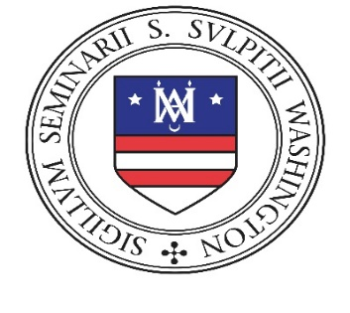
Theological College Seminary

presents our

9th ANNUAL SEDES CUP GOLF CLASSIC

Tuesday, OCTOBER 25, 2022

TURF VALLEY RESORT

SPONSORSHIP LEVELS

□ Awards Luncheon $1,000 □ Golf Tees $500
*□ Gold Sponsor $5,000 □ Boxed Breakfast $1,000 □ Golf Balls $500
*□ Silver Sponsor $4,000 □ Snack & Beverage Cart $1,000
*□ Bronze Sponsor $3,000 □ Seminarian Foursome $1,000 (includes club rentals)
* Includes Golf Foursomes: Please fill out golfer registration form.

SPONSORSHIP AGREEMENT

I, , on behalf of (company/organization) wish to support the 9th Annual Sedes Cup with a sponsorship in the amount of $____________.
Signature: Date:
CONTACT INFORMATION
Name: Company:
Mailing Address:
City: State: Zip:
Phone: Email:
Please make checks payable to
Theological College
and send completed form along with payment to:
Theological College
Sedes Cup Golf Classic
401 Michigan Ave, NE
Washington, DC 20017
Please direct any questions about the Sedes Cup Golf Classic
to Mary Nauman, TC Development Office, at
(202) 756-4905 or nauman@cua.edu

